Group Project – Game Genre research Week 1

Group Project Brief:

1. The Game is a single player game
2. We must consider a genre of game or type of games that have a typical mechanic or set of mechanics
3. We must develop a game without a specific mechanic or mechanic set
4. We must then Substitute that mechanic with a new solution to the problem that removing the mechanic creates for the game.
5. We must put emphasis on a single mechanic.

The game must be delivered:

1. It must be a game that is self-contained and needs no explanation from the developer to play.
2. We must put emphasis on the gameplay experience
3. The game must abstract itself from other games of the same genre by removing a key mechanic

|  |  |
| --- | --- |
| What genre of game are we choosing? | Platformer |
| What mechanic are you changing? | Manual character Jumping Mechanic |
| What mechanic are you changing it to? | Invisibility/Hiding mechanic |
| What emotions are we looking for in game? | Frustration and relief. These will come from players quickly dodging enemies by turning invisible and hiding behind objects. |
| What are the key design problems we will face? | Making the game quick and not boring as jumping can speed up game and gives players more control so including a different mechanic to replace this may be difficult. |
| What are the key Programming issues we will face with our game? | Programming Invisibility mechanic and programming character to only be able to hide behind certain game objects. |
| Player feedback (1) | The game Keeps its genre of a Platformer even without the jumping game mechanic as the invisibility/hiding game mechanic allows players to quickly and enjoyably dodge enemies in the game. |

Game Genres:

**Platformer:** The mechanic that could be removed:

1. **A lives system for when a character loses which ends the game** where instead we could add a timer or time limit for when each level must be completed E.g. A Fast-paced platformer that has a high score table for each level in game for when they complete it which adds competition between players.
2. **Jumping –** This mechanic is used in platformers so they can avoid enemies and not get killed or lose a life in the process. This can be removed by added a feature such as a mechanic that lets your turn invisible for 5 seconds and has a cool down time of 2 seconds, so you have time to avoid enemies. Another idea is that the player can hide behind certain items in game to protect themselves and they can use ladders to get to different floors.

|  |  |
| --- | --- |
| What genre of game are we choosing? | Platformer |
| What mechanic are you changing? | Lives system |
| What mechanic are you changing it to? | Time limit/timer mechanic so instead of having any lives if a player is killed, they will just start the level at the beginning or from a check point while the timer is still counting down. |
| What emotions are we looking for in game? | Tension and Relief these will be enabled by players looking at the timer and making sure they are saving time by doing different things in different levels that would save time. |
| What are the key design problems we will face? | Making sure that the timer works when the level starts and making sure we identify how long a level should take at the amount we should give a player for each level due to a change in difficulty in each level. |
| What are the key Programming issues we will face with our game? | Programming the timer to tell the player once it runs out the level is over, and the player is lost and respawning the character at a checkpoint or beginning of the level once hit by an enemy. |
| Player feedback (1) | The Game still includes the correct amount of challenge without a lives system instead with a time limit that creates frustration and stress emotions due to players ether running out of time fast or they keep dying and going back to a certain part of the level while the time limit does not stop. |

**2D shooters:** The mechanic that could be removed:

1. **Firing weapons –** This mechanic is the biggest part of this game genre in terms of mechanics so removing this may be difficult but instead we could include a mechanic that lets player deflect enemies fire by using a super shield that would deflect enemy attracts and kill them instead of you killing them yourself.
2. **Collectables –** In many shooting games such as shooting games they normally have collectables which can help you complete the game or make your character stronger we could remove this mechanic from the game and add a mechanic where once a player has killed a certain number of enemies or certain types of enemies their guns slowly upgrade which then adds information about the guns In another menu.

|  |  |
| --- | --- |
| What genre of game are we choosing? | 2D Shooter |
| What mechanic are you changing? | Shooting |
| What mechanic are you changing it to? | Reflecting/Deflection |
| What emotions are we looking for in game? | A game that gives players emotions of challenge and frustration as they must be able to time when they should deflect an opponent’s attack/ projectile. |
| What are the key design problems we will face? | Making the 2d shooter as fun as game that includes shooting enemies to kill them as deflecting may not be as enjoyable or may not provide interesting gameplay. |
| What are the key Programming issues we will face with our game? | Programming how the character in game should be able to reflect shooting attacks in game and the timer for when the character has successfully deflected the attack in proportion to when the player clicked the deflection key. |
| Player feedback (1) | The Game is a different/fun version of a 2D shooter as it uses deflection to kill enemies rather than firing a weapon to kill enemies. |

|  |  |
| --- | --- |
| What genre of game are we choosing? | 2D Shooter |
| What mechanic are you changing? | Collectables |
| What mechanic are you changing it to? | Upgrades |
| What emotions are we looking for in game? | Excitement, enjoyment, and relief as one player upgrade guns they can finally kill enemies quicker. |
| What are the key design problems we will face? | Designing and making each gun in game make them be given to a player character once they get enough kill or kill a certain character. |
| What are the key Programming issues we will face with our game? | Programming each of the guns, the fire rate of the guns and making sure the character in game gets a different type of gun as the amount of kills they get go up. |
| Player feedback (1) | This game rewards players for getting higher amounts of kills and seeks to get the best guns in the game for player for longer and clearing out levels. |

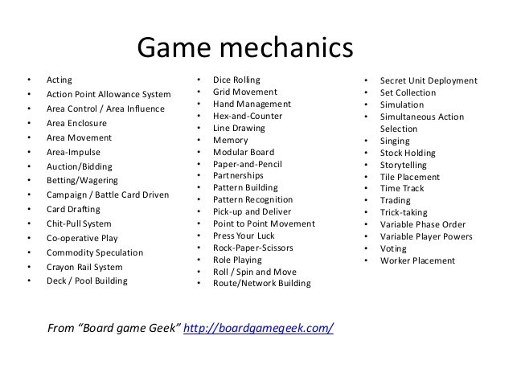

First person shooter: The mechanic that could be removed:

1. Vision – This part of the game could be quite hard to remove but we could add a mechanic where the character in the game at super hearing and can hear around his surroundings which gives a player a wireframe type vision, they outline people that maybe nearby.

|  |  |
| --- | --- |
| What genre of game are we choosing? | First Person Shooter (FPS) |
| What mechanic are you changing? | Vision |
| What mechanic are you changing it to? | Enhanced Audio mechanics |
| What emotions are we looking for in game? | A game that provides Tension, relief and stress from the idea of the visual mechanics being removed causing players to create a new way of playing games by listening to audio queues. |
| What are the key design problems we will face? | Trying to design and use sound in game to help players as the visual mechanic has been removed/ changed. It will also be difficult to include something that players can look at on screen while playing (wireframe of surroundings could be a good idea or footstep icons when someone’s nearby. A Map and location could also be included. |
| What are the key Programming issues we will face with our game? | Programming enemy characters UI, also programming character movement. |
| Player feedback (1) | The Game has enhanced gaming by using fewer visual mechanics by using sound to direct people in where enemies are. Footsteps can also be seen on screen and by audio which increases in volume when someone is nearby. |

Stealth Game: The Mechanic that could be removed:

Manual Movement: This mechanic could be removed and replaced with a dice rolling mechanic where depending on there dice rolls it will determine the outcome.

|  |  |
| --- | --- |
| What genre of game are we choosing? | Stealth Game |
| What mechanic are you changing? | Manual Movement |
| What mechanic are you changing it to? | Dice rolling |
| What emotions are we looking for in game? | Accomplishment, tension relief created by the luck rolling dice-based mechanic. |
| What are the key design problems we will face? | Creating a Stealth game that relies on luck for their movement but uses dice that also contain certain pictures on certain sides on the dice that gives players different power ups and sometimes negative outcomes. |
| What are the key Programming issues we will face with our game? | Programming virtual dice that will determine the movement of the character in the game but also making the game not just luck based as it can make the game less fun so adding a skill mechanic to the game besides this will make the game more balanced. |
| Player feedback (1) | This game has a twist on more modern day stealth games as it uses a luck mechanic to determine the characters outcome which makes the game fun and keeps people understanding that they are always in danger as luck can go ether way. |